From Tima’s Desk: Does the Coronavirus Offer Lessons for Climate Change?

The coronavirus, or COVID-19, and climate change are very different problems. But the global response to the coronavirus gives me hope that we can tackle other global threats.

Dr. Tima Bansal is Executive Director of the Network for Business Sustainability.

It is hard to see the positive in the novel coronavirus and its associated disease, COVID-19. Not only has COVID-19 made people very sick, it has exposed our vulnerability to global threats.

There’s chaos and devastation in the wake of COVID-19. But, there are also a few bright spots, including the drop in pollution and the strengthening of local communities.

One positive outcome that I have not seen mentioned is the demonstrated ability of the global community to act quickly. Even if governments have been slow to act, many individuals have responded swiftly. This mobilization may, in fact, be the most important learning of all.

My Personal Decision Related to COVID-19
A few weeks ago, I and the other organizers of the NBS Sustainability Centres Workshop decided to postpone the June 2020 workshop in Vienna. The decision seemed easy at the time, even though few other events had been cancelled and only a few thousand people had COVID-19, primarily in China.

Our logic was straightforward. Researchers were unlikely to develop a vaccine quickly, so in order to slow the spread of the virus, participants would either stay away from the conference voluntarily or be forced to do so. We wanted to be part of a global community showing responsibility.

Since our decision to cancel our event, there has been a cascade of cancellations, including major music festivals and sporting events. The financial losses and personal disappointments are staggering. But, people have rallied around the need to prevent a global catastrophe that could hurt or kill millions.

COVID-19 has focused society’s attention
The degree to which COVID-19 has captured the attention of the world is truly remarkable. Many of us are pinned to newscasts, watching the numbers of sicknesses and fatalities tick upwards each day, as different countries jostle for the top or bottom spots (greatest or least increase in infections).

Without doubt, the public’s response has been visible and swift. There are few people in the world who are unaware of the virus.

COVID-19 has some positive outcomes
The attention has changed the way in which people live and work. People with flexibility are canceling meetings or taking them online. We are moving around less and spending time at home. Even professors, who are risk averse and sometimes slow to change, are learning to teach online — within just days. People are collectively working to safeguard not only ourselves, but our neighbours and community.

On the environmental side, the BBC showed satellite images of the pollution over all of China and over Wuhan before and after the COVID-19 outbreak. Red spots representing pollution before the outbreak were erased in the days after the outbreak.

It is quite likely that pollution will return once the threat of the virus subsides, but the magnitude of the response demonstrates the ability to mobilize quickly under a global threat.

How COVID-19 differs from climate change

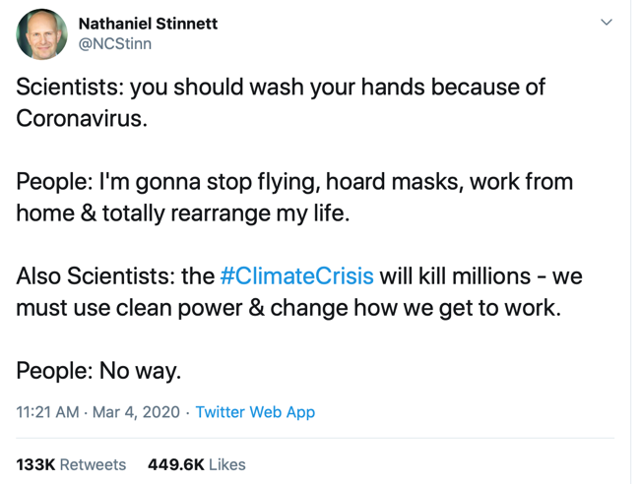

The irony in Nathaniel Stinnet’s tweet (see inset) is apparent. People are willing to respond to COVID-19, but not climate change, which is the greater threat to our species and millions of others. Climate change is what is known as a ‘wicked problem’, whereas COVID-19 is not.

For COVID-19, the causality is clear. The virus transmission and its effect can be monitored, which allows it to be isolated and controlled. As well, the time frames are short — so symptoms generally appear in just a few weeks. We even know how to slow the spread of the virus — avoid infected people, wash your hands, and don’t touch your face. The answer is at our fingertips (sic!).

Climate change is different. It has numerous causes (anything that emits or absorbs greenhouse gases) and numerous impacts (rising temperatures being just one). Greenhouse gases have been accumulating in our atmosphere for hundreds of years, so it is difficult to clearly link the causes with the effects, making the effects difficult to isolate and control. There are no quick or simple fixes. We can’t just wash our hands and take our meetings from home.

Yet, COVID-19 gives me hope about climate change
I suffer from seeing despair and optimism in almost everything — an occupational hazard of studying sustainable development. COVID-19 has elicited the same in me.

I despair over the damage caused by a pandemic that causes sickness and death. How can I not?

But, I also see some hope. People have focused attention worldwide on a single issue and have adapted the way in which they live and work in a very short period of time.

Sure, COVID-19 is a simpler, more visible, and seemingly more urgent issue, but climate change is rising to the same level. People are now seeing the devastation caused by a changing climate.

It is just possible that once the threat of COVID-19 has passed, we will have learned how to focus attention on issues of global concern. Both traditional and social media can start to focus attention on climate change, as they have with COVID-19.

With all the despair caused by COVID-19, I now feel that the global community can mobilize around an issue. COVID-19 has created a global sense of responsibility. I do hope that this common purpose can extend to other significant threats facing humanity and the planet.

Continuing the Conversation

As always, I welcome your reactions. Please feel free to message me (@TimaBansal, tbansal@ivey.ca) or the NBS community (@NBSnet) privately or publicly.

More From Tima’s Desk
Dr. Tima Bansal, NBS's Executive Director, regularly shares her observations about business sustainability. See the series.

