Stockpiling Bottled Water? Maybe Social Media is To Blame

Jaigris Hodson, PhD, Associate Professor, Royal Roads University
Contact: jaigris.hodson@royalroads.ca

Sarah Wolfe, PhD, Associate Professor, University of Waterloo, and Visiting Professor, Royal Roads University
Contact: Sarah.1wolfe@royalroads.ca
It’s a common sight in stores across Canada: empty shelves where bottled water used to be. Online, bottled water is selling online for anywhere from $30 to $75 a case as people panic-buy supplies. But why the sudden rush on bottled water in places with high functioning infrastructure?
Public health authorities have suggested all Canadians stock up on enough essentials -- staples like beans, rice and flour, pet food, and hygiene products. Their recommendations do not include bottled water since for most Canadians --with the exception of the ongoing, unacceptable boil-water advisories in many Indigenous communities – municipal tap water is abundant and safe to drink.
Stockpiling bottled water is unnecessary. It’s highly unlikely that our municipal water systems will fail. The water industry has recognized for more than a decade that it had an impending wave of retirements and has been actively recruiting and training younger water utility professionals. Given that the virus is generally milder for this demographic, most water professionals will still be able to work. Drinking water provision in most of Canada is also an essential service like energy and medical services.
So why then are people stockpiling bottled water?
For the COVID-19 crisis, anxiety and fear is likely driving social media posts about the necessity to stock up on bottled water and essentials. In times like these, people are driven to search for answers to an ill-defined and threatening situation. People search for and share misinformation because they’re afraid and they’re looking for answers.
The nature of the threat may play a role too, particularly when it relates to mortality. The increasingly dire COVID-19 headlines and daily death counts can trigger powerful fears that hinder “rational” responses. Social psychology research shows that reminders of our mortality generate vigorous psychological defenses designed to repress our death awareness. This arsenal ranges from outright denial, distraction and consumption behaviours that could trigger panic buying and the so-called ‘herd mentality.’
These instinctive and understandable fears and defenses are exacerbated by misinformation flowing across digital platforms of all kinds, including social media.
We can’t say definitively where the advice to stockpile bottled water originated, but in Canada, the Region of York suggested people stock up Feb. 27. Whether that was the original source, the advice has taken on a life of its own on social media. The hashtag #bottledwater was used 234,575 times between March 12 and March 16 according to TweetArchivist.com, with reporters from as far as Los Angeles sharing #bottledwater related tweets. Some of these posts were spreading advice to buy bottled water. A great many others were trying to contradict the advice.
Repeating bad information, even in an attempt to counter it can inadvertently amplify it, can backfire and reinforce the original idea. When we reviewed a sample of tweets that tried to call out others for stockpiling bottled water, most of the tweets included the now ubiquitous image of empty aisles.
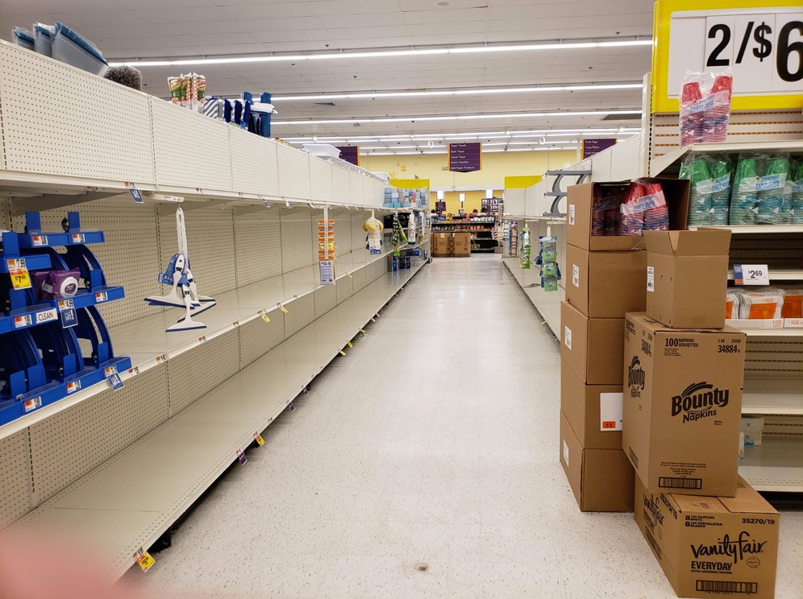
An image of empty store shelves, posted to Twitter the week of March 9
These posts and images do more harm than good: people scrolling through Twitter will see only that other people are buying bottled water. The herd instinct kicks in and we feel like we must do the same thing. Social media amplification impacts our perception of the situation.
How can we change our information habits so that misleading information is less likely to spread during anxious times? The answer starts with each and every one of us challenging our own assumptions and remembering to SIFT online information. SIFT, developed at Washington State University, refers to following the following steps: Stop. Investigate the source. Find better coverage. Trace claims.
If you see COVID-19 related information online, and particularly if someone shares something with you that sounds like it could be true, check its veracity before you share it with others. In COVID-19-related social media overload, you may not be able to find the source, but can use a modified SIFT framework: Stop-Think-Verify. Stop, when you see or hear a claim that feels true. Think, critically assessing if the claim and the source of the claim. Verify by going to a trusted and vetted source (in this case Health Canada or the World Health Organization) to find trusted evidence.

