What Does “Flattening the Curve” Mean? Will It Also Flatten the Global Economy?

Available at Globalbusiness.blog:
https://globalbusiness.blog/tag/flattening-the-curve/

Includes additional references from medical experts and economists for those who wish to read deeper

Farok J. Contractor, Rutgers Business School April 5, 2020

The Excruciating Choice

Governments face an “excruciating choice” between “flattening the (coronavirus) curve” by imposing quarantines and lockdowns and the huge, unprecedented economic impact on the world economy that is already in recession. The Health and Human Services Department of the US Federal Government is planning for the possibility of an 18-month medical and economic crisis (Bublé, March 18, 2020).

While pandemics have occurred in the past, the global scale of overnment response verges on the unimaginable. According to a Pew Research Center report, as of March 31, 2020, 93 percent of the world’s population lived in countries with at least some travel restrictions (Connor, April 1 2020). This means that much of the world economy is either hampered, delayed, or shut down entirely (Fernandes, March 22, 2020). In the worst scenario, if prolonged, this could lead to not just a global recession, but something worse.

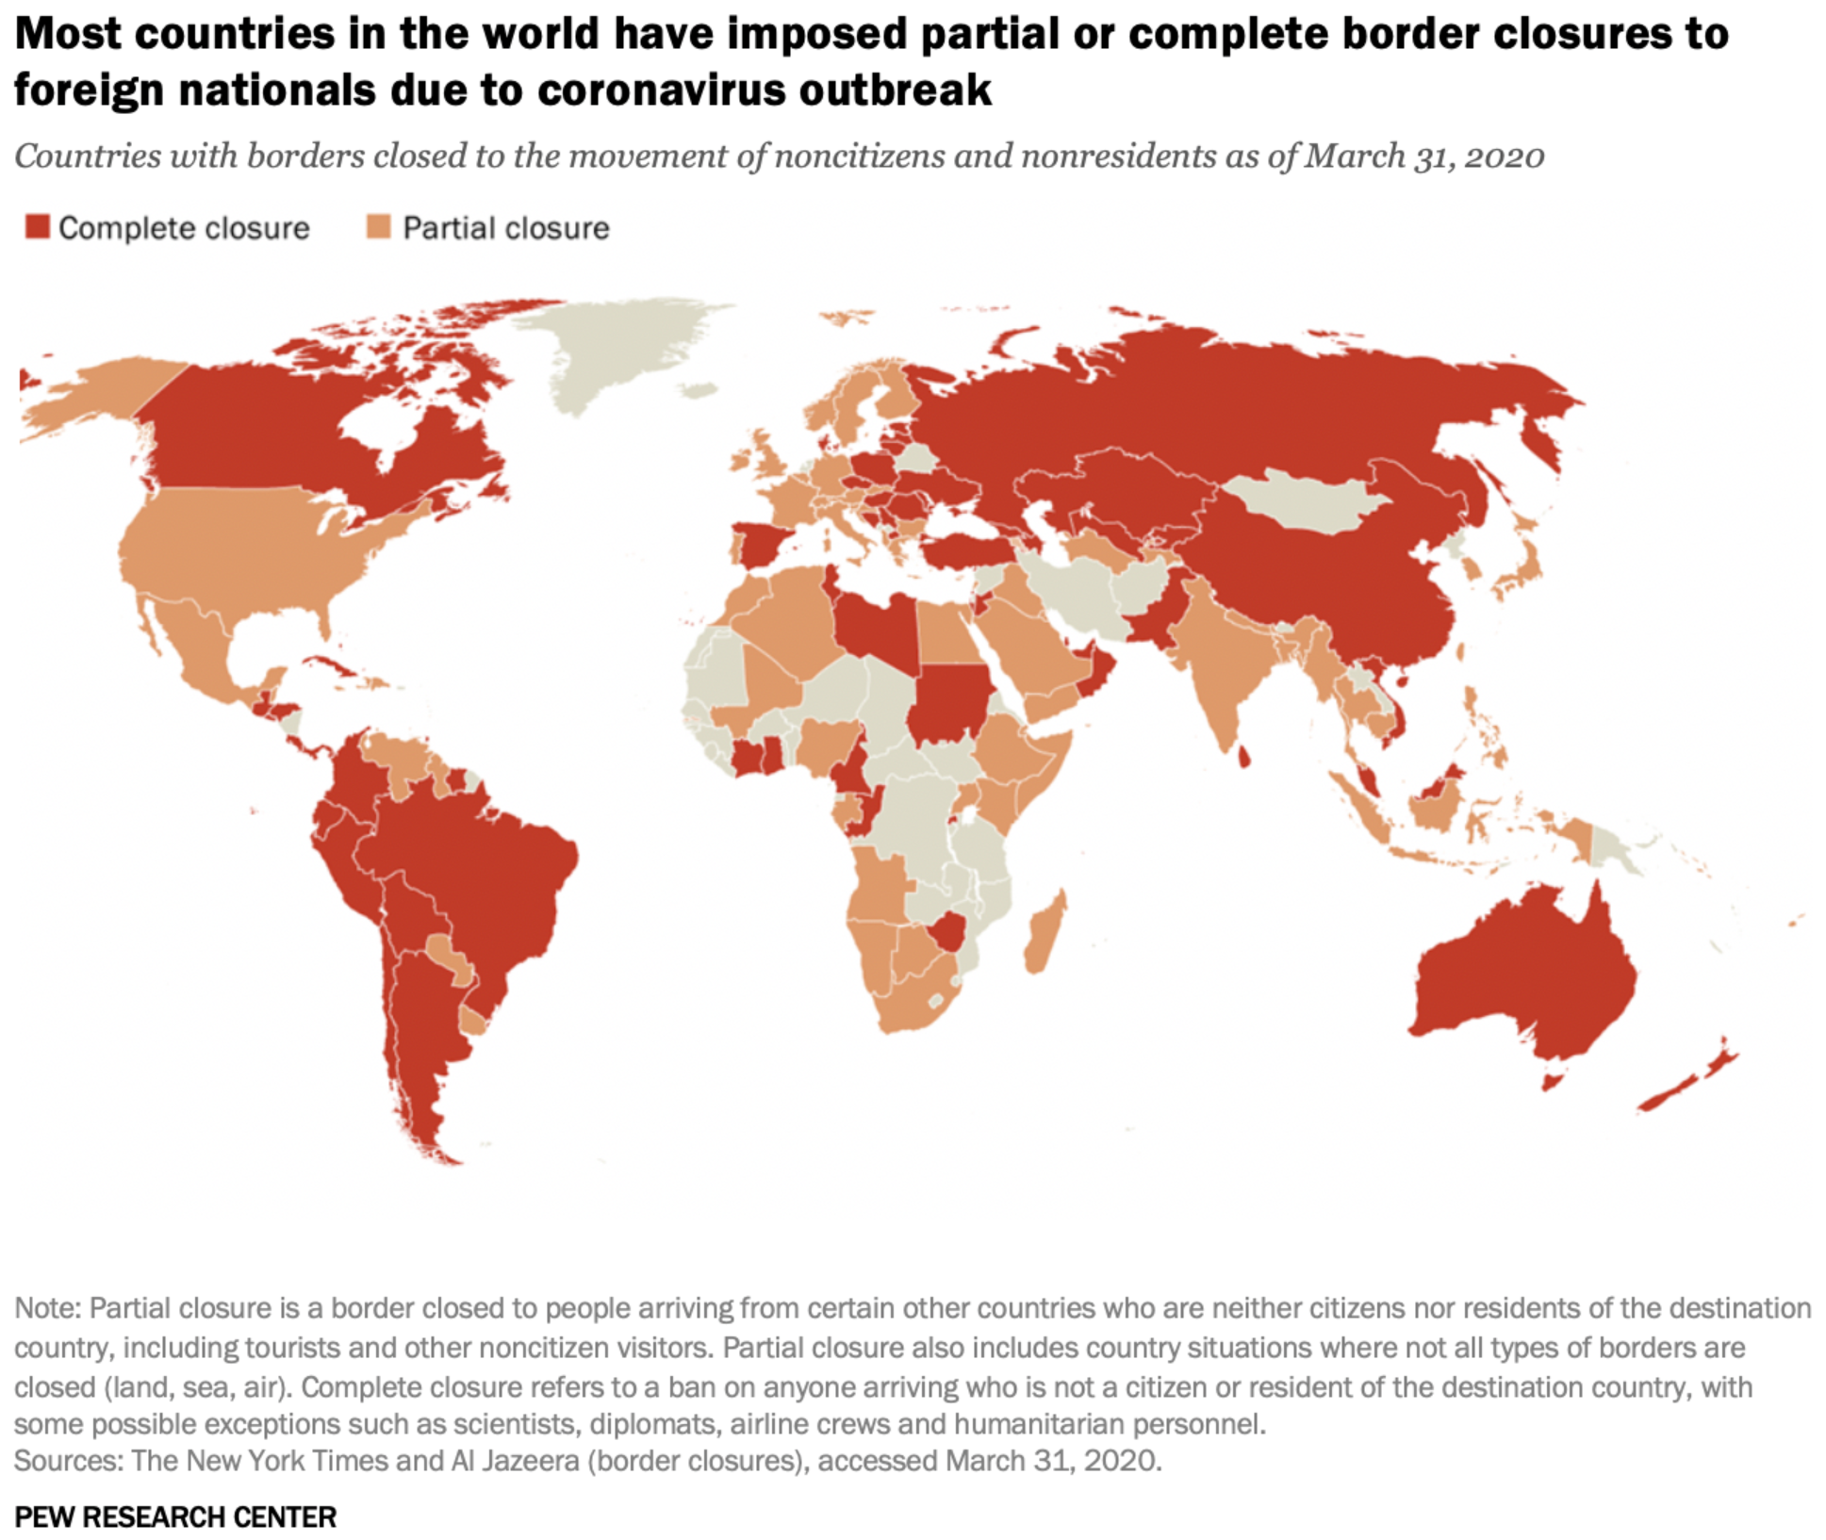

Source: Connor, P. (April 1, 2020). More than nine-in-ten people worldwide live in countries with travel restrictions amid COVID-19. Pew Research Center. https://www.pewresearch.org/fact-tank/2020/04/01/more-than-nine-in-ten-people-worldwide-live-in-countries-with-travel-restrictions-amid-covid-19/

Are the “Copycat” Government Responses Worldwide Appropriate or Excessive?

What is driving this “copycat” behavior on the part of all nations? Is it an excessive reaction? What will be the consequence– returning to normalcy faster or plunging the world into a prolonged recession? Governments are closing businesses and imposing quarantines or travel restrictions with the idea of slowing the spread of the coronavirus. But will slowing its spread also prolong the economic anguish? Will it also reduce the number of persons eventually infected?

For readers interested in the above questions, this piece is intended as another update to my earlier post (Contractor, March 20, 2020) with additional references from medical experts and economists. I also indicate below why there are no definitive answers yet (Knowledge@Wharton, March 24, 2020) and why the estimates in the scholarly epidemiological references below should be read with circumspection.

What Does “Flattening the Curve” Mean?

The expression “flattening the curve” is already a popular cliché. What a government means by this – and it is an admission of unpreparedness – is that, unchecked, infections would grow at an exponential rate so as to exceed the capacity of hospitals to cope with the numbers of patients. For a graph and additional details, see my earlier post (Contractor, F., March 20, 2020).

By forcing quarantines and social distancing, governments hope that the growth of the infections will slow to a rate that remains below the maximum capacity of hospital beds, equipment such as ventilators, and doctors and nurses available in their region or country. If not, the medical establishment will be overwhelmed. This is already happening in Italy, Spain, New Delhi, and New York (as of April 2, 2020). For a while, it happened in Wuhan and Hubei Province, whereupon the Chinese government introduced a severe lockdown on January 23, 2020.

But What About the Severe Impact of Shutting Down Some or Much of the World Economy?

While restrictions are being gradually eased in Hubei, scant signs of an economic recovery there are evident as yet. As the diagram in my previous post (Contractor, March 20, 2020) schematically illustrates, “flattening the curve” also means prolonging the economic dislocation, precipitating mass unemployment (perhaps more than 60 million have been laid off worldwide in just the last two weeks), bankruptcies, and the mental and physical health effects of an extended downturn in the medium to long term.

Are Governments Acting Appropriately or Over-Reacting?

Candidly, we have no definitive answers as yet. While economic papers (e.g., Bonaparte, 2020; Fernandes, 2020; Gourinchas, 2020) try to model the effects, all modeling is based on assumptions, and the current situation poses way too many unknowns or gaps in data (Stock, 2020). For example:

- Using the 1918 pandemic experience as an example is hardly analogous.
- The coronavirus is different, and its virulence, mutation rate, propensity to linger in warmer weather, persistence, and return are unknowns at present.
- The world of 2020 is vastly more globalized and interdependent than ever before.
- Supply chains in world trade are orders-of-magnitude more complex. Subcomponents, parts, and components cross country borders multiple times before being finally assembled, all under the aegis of multinational companies (MNCs). For example, UNCTAD (2013) estimated that in 80 percent of all world trade (amounting to around $US 20 trillion in 2019), a MNC was either an exporter or an importer, on one side of the trade deal, or participated as an orchestrator of a global value chain. Equally remarkably, the same MNC was both the importer and the exporter (i.e., simultaneously on both ends of the shipment) in approximately 40 percent of world trade, and Lanz and Miroudot (2011) found that in 2009, 58 percent of US goods imported from OECD countries were intra-firm.
- With 93 percent of the world’s population living in countries with restrictions imposed because of the virus, the scale of this slowdown or shutdown is utterly unprecedented.
- Companies, municipalities, and individuals are more vulnerable because, tempted by historically low interest rates post-2008, many borrowed recklessly, and their leverage or debt:equity ratios are dangerously near record highs (Srivastava, 2019).
- Epidemiological modeling (e.g., Flaxman, Mishra & Gandy, 2020, or Correia, Luck & Verner, 2020) is also prone to greater uncertainties because the behavior of the current virus is not exactly mapped yet.
- The world population is at an all-time high of 7.7 billion.
- Crowding or urbanization now includes over 60 percent of humanity, which is at a record level.
- Average temperatures worldwide are higher, which may decrease the incidence of certain viruses, but increase disease transmission in general (World Health Organization, 2020; Luber, et al., 2014).
- In 2019, 4.7 billion airline tickets were sold, and cross-border tourist visits numbered more than 1.5 billion.
- All of the above elements point to increased vulnerabilities of the global economy, but on the positive side, 3.2 billion − or almost half the planet − had access to the internet, were better informed and more educated, and were more likely to comply with government orders or recommendations.

The degree of uncertainty in modeling is illustrated in Flaxman, Mishra & Gandy (2020) and in The Economist (April 1, 2020), where the “95% confidence” interval is itself as broad as 50 percent for more than half of the countries studied.

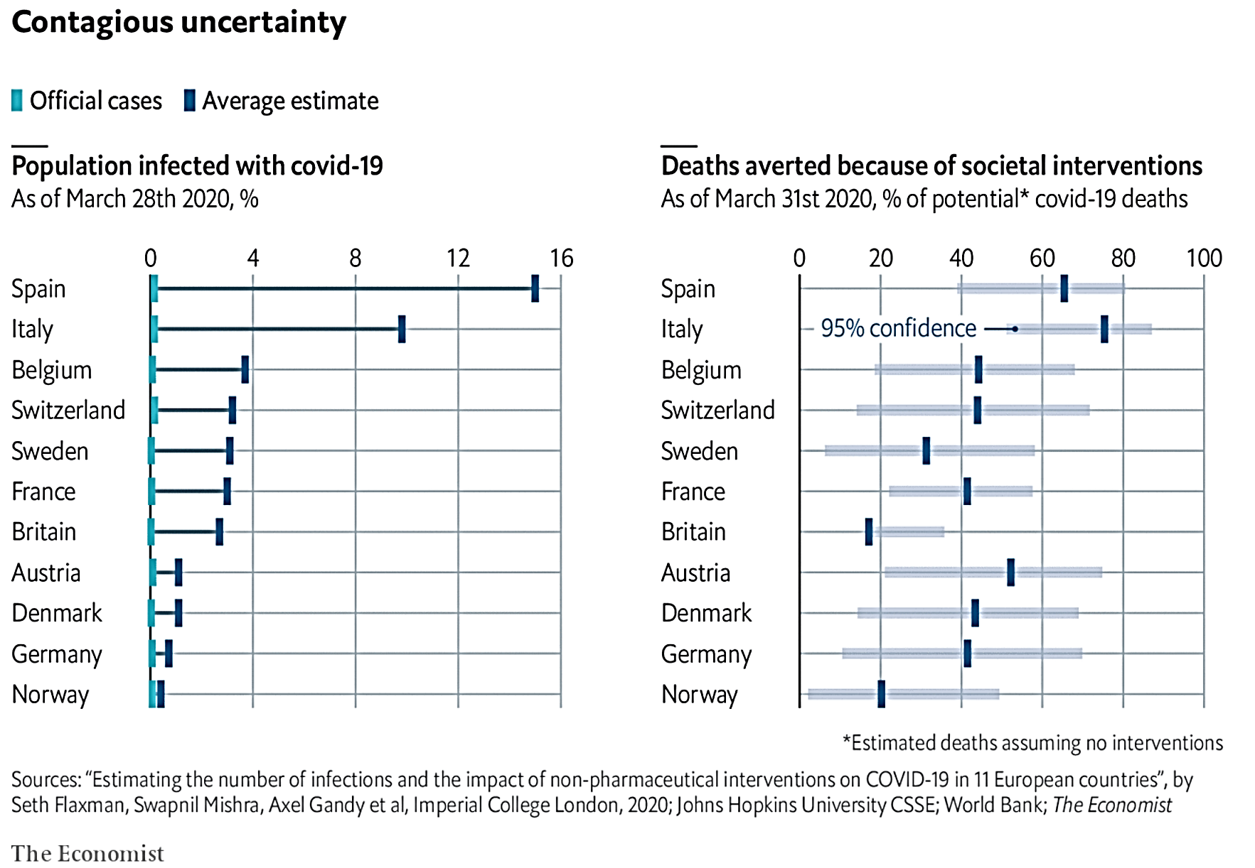

Source: The Economist, April 1, 2020. https://www.economist.com/graphic-detail/2020/04/01/covid-19-may-be-far-more-prevalent-than-previously-thought

The degree of uncertainty even among medical experts is demonstrated by the estimate in the above chart, For instance, for Germany the mean “% of potential covid-19 deaths” averted is estimated at 41 percent, but the 95 percent confidence interval ranges widely from 12to 70. For Belgium, the mean is 44, but the confidence interval ranges from 18to67. This is true for most of the countries studied.

How History Will Judge This Period

For interested readers, my earlier post (Contractor, March 20, 2020) describes the trade-offs and the excruciating dilemma for governments and describes the logic behind “flattening the curve.” In short-term health effects, there is no question that shutdowns and quarantines are the right thing to do, according to Gourinchas (2020), Correia, Luck & Verner (2020), and this graph in The Economist. But “flattening the curve” also means prolonging the world recession to an unknown extent, which itself may have grave long-term economic and health consequences. Only history will judge whether the trade-off was appropriate.

In Conclusion: Will Globalization Retreat?

For International Business, 2020 will be remembered as an inflexion point that adjusted or restructured MNC operations, global value-chains, the role of governments in regulating foreign direct investment (FDI), protectionism, the change in the behavior of managers to take risks (i.e., the uncertainty-avoidance behaviors of managers), propensity to form cross-border alliances, country-of-origin influences on consumer purchases (Samiee, Shimp & Sharma, 2005), and myriad other global business decisions – thus formulating a new agenda for the future of globalization.

Will globalization retreat? Probably not. Although there likely will be more national controls, local value-added mandates, and nationalism, the underlying logic of global business will remain valid. What is the underlying logic? Specialization and concentration – the idea that certain types of products or services, or certain functions, are more efficient (i.e., cheaper) when concentrated in certain countries or cities, from where they can be distributed locally and internationally. The opposite model – each nation trying to make everything domestically – is not only far more expensive, but also simply not feasible for most of the smaller nations on the planet.

Politics and global economics will remain in uneasy tension. The number of countries on the surface of our planet (193 at last count in 2020) is three-and-a-half times larger than the number of nations that existed in 1960. But that did not stop the phenomenal expansion of trade and FDI over the past 60 years. Nationalism and concocted patriotism course through Facebook, Twitter, Instagram, and WhatsApp. But each message recipient also knows – subconsciously – that the smartphone they are holding in their hands would cost three to ten times more if produced entirely locally.

As a consumer, which is more important to you? The satisfaction of a smug national or local identity with most products and services costing much more than they do today? Or the slight psychological discomfort that internationalization causes for your identity and self-worth* while you enjoy lower prices and consequently a higher standard of living in material terms? I leave that as an open question for the future (and future blog posts).

*See my previous posts: What Is Globalization? How to Measure It and Why Many Oppose It (Part 1) and Global Leadership in an Era of Growing Nationalism, Protectionism, and Antiglobalization (Part 2).

REFERENCES

Bonaparte, Y. (March 5, 2020). Pricing the Economic Risk of Coronavirus: A Delay in Consumption or a Recession? Available at SSRN: https://ssrn.com/abstract=3549597 or http://dx.doi.org/10.2139/ssrn.3549597

Bublé, C. (March 18, 2020). Coronavirus Roundup: Federal response could last 18 months. Government Executive. https://www.govexec.com/workforce/2020/03/coronavirus-roundup-news-about-outbreak-matters-feds/163882/

Connor, P. (April 1, 2020). More than nine-in-ten people worldwide live in countries with travel restrictions amid COVID-19. Pew Research Center. https://www.pewresearch.org/fact-tank/2020/04/01/more-than-nine-in-ten-people-worldwide-live-in-countries-with-travel-restrictions-amid-covid-19/
Contractor, F. (March 20, 2020). The excruciating choice: “Flattening the curve” and prolonging the global recession. GlobalBusiness.Blog https://globalbusiness.blog/2020/03/20/the-excruciating-choice-flattening-the-curve-and-prolonging-the-global-recession/ (updated March 23, 2020: https://globalbusiness.blog/2020/03/23/quick-update-the-excruciating-choice-flattening-the-curve-and-prolonging-the-global-recession/).

Correia, S., Luck, S. & Verner, E. (March 30, 2020). Pandemics Depress the Economy, Public Health Interventions Do Not: Evidence from the 1918 Flu. Available at SSRN: https://ssrn.com/abstract=3561560 or http://dx.doi.org/10.2139/ssrn.3561560

Fernandes, N. (March 22, 2020). Economic Effects of Coronavirus Outbreak (COVID-19) on the World Economy. Available at SSRN: https://ssrn.com/abstract=3557504 or http://dx.doi.org/10.2139/ssrn.3557504 or https://mediaroom.iese.edu/wp-content/uploads/2020/03/Fernandes-Nuno_20200322-Global-Recession-is-inevitable.pdf

Flaxman, S., Mishra, S. Gandy, A. et al. (March 30, 2020). Estimating the number of infections and the impact of nonpharmaceutical interventions on COVID-19 in 11 European countries, Working Paper, Imperial College COVID-19 Response Team DOI: https://doi.org/10.25561/77731

Gourinchas, P-O. (March 18, 2020). Flattening the pandemic and recession curves. Mitigating the COVID Economic Crisis: Act Fast and Do Whatever It Takes. Available at: VOX. https://voxeu.org/content/mitigating-covid-economic-crisis-act-fast-and-do-whatever-it-takes

Pandemic Panic: Can governments protect jobs and markets? Interview with Mauro Guillen (March 24, 2020). Available at:

https://knowledge.wharton.upenn.edu/article/layoffs-loom-governments-respond-pandemic-panic/

Lanz, R. & Miroudot, S. (2011). Intra-Firm Trade. Patterns, Determinants and Policy Implications. OECD Working Paper No. 114. https://www.researchgate.net/publication/241764228_Intra-Firm_Trade_Patterns_Determinants_and_Policy_Implications

Luber, G., K. Knowlton, J. Balbus, H. Frumkin, M. Hayden, J. Hess, M. McGeehin, N. Sheats, L. Backer, C. B. Beard, K. L. Ebi, E. Maibach, R. S. Ostfeld, C. Wiedinmyer, E. Zielinski-Gutiérrez, & L. Ziska, 2014: Ch. 9: Human Health. Climate Change Impacts in the United States: The Third National Climate Assessment, J. M. Melillo, Terese (T.C.) Richmond, and G. W. Yohe, Eds., U.S. Global Change Research Program, 220-256. doi:10.7930/J0PN93H5 https://data.globalchange.gov/report/nca3/chapter/human-health

Samiee, S., Shimp, T. A. & Sharma, S. (2005). Brand origin recognition accuracy: Its antecedents and consumers’ cognitive limitations. Journal of international Business studies, 36(4), 379−397. https://www.researchgate.net/publication/5223148_Brand_origin_recognition_accuracy_Its_antecedents_and_consumers'_cognitive_limitations

Srivastava, S. (November 15, 2019). Global debt surged to a record $250 trillion in the first half of 2019, led by the US and China. CNBC.com. https://www.cnbc.com/2019/11/15/global-debt-surged-to-a-record-250-trillion-in-the-first-half-of-2019-led-by-the-us-and-china.html

Stock, J. H. (March 26, 2020). Data gaps and the policy response to the novel coronavirus (No. w26902). National Bureau of Economic Research.

https://heep.hks.harvard.edu/files/heep/files/dp_82_stock_data_gaps_policy_response_novel_coronavirus.pdf

The Economist (April 1, 2020). Daily Chart: Covid-19 may be far more prevalent than previously thought.
The Economist (March 31, 2020). Daily Chart: Lessons from the Spanish flu: social distancing can be good for the economy.

UNCTAD (2013). World Investment Report: Global Value Chains, Investment and Trade for Development. Geneva: United Nations. https://unctad.org/en/PublicationsLibrary/wir2013_en.pdf

World Health Organization (accessed April 2, 2020). Climate Change and Human Health. https://www.who.int/globalchange/climate/summary/en/index5.html.

