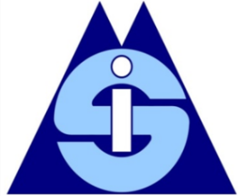
The SIMian
June 2023

Contents
EDITORS’ NOTE 2
2022-2023 PROGRAM CHAIR’S MESSAGE 3
2023 SIM COMMITTEES AND CONSORTIA 5
2023 SIM-ONE JUNIOR FACULTY CONSORTIUM 5
2023 SIM DOCTORAL CONSORTIUM 7
2023 SIM MEMBERSHIP COMMITTEE REPORT 9
ACKNOWLEDGEMENT 11

EDITORS’ NOTE

Dear SIMians,

We hope you have had an impactful and healthy 2023 so far. This issue of The SIMian newsletter is more limited in scope than previous newsletters. It includes information regarding SIM-specific programming at the 2023 Annual AOM Meeting in Boston, MA, USA, as well as brief updates from select SIM committees.

The next issue of The SIMian will be published following the 2023 Annual AOM Meeting, and will focus on reviewing the Annual Meeting from a SIM perspective. We also plan to feature calls for participations and other announcements that are relevant to the broader SIM community, so please forward any items you would like included to as at: The.SIM.Editor@gmail.com. Please only include contributions in MS-WORD format or as text in an email (not in PDF format).

If you have questions or comments, feel free to contact us at The.SIM.Editor@gmail.com.

We hope you enjoy the issue!

David J. Skandera, Virginia Commonwealth University
Jae Hwan Lee, Rollins College
The SIMian Co-editors

2022-2023 PROGRAM CHAIR’S MESSAGE

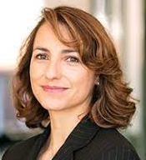
Michelle Westermann-Behaylo
University of Amsterdam

Dear SIM members,

Now that the Spring semester is just about wrapped up, we hope you are anticipating the Summer, including the very exciting SIM program planned in Boston. We look forward to reconnecting with you there, as the AOM conference will once again be fully in person (with some limited accommodations for remote access). Your SIM leadership is pleased to announce our scholarly program including PDWs, paper sessions, symposia, and events to promote both learning about new research, career development, and networking with fellow SIMians. This year the SIM PDWs and consortia will occur on Friday August 4th and Saturday August 5th, and the scholarly program of symposia, plenary sessions and paper sessions will take place from Sunday August 6th to Tuesday August 8th. And of course, our SIM Business Meeting and SIM Social are planned for Monday August 7th, so please put that high on your agenda.

We are very grateful to everyone who helped put the SIM program together, and especially want to give a heartfelt thank you to all the reviewers. In total, 495 people signed up to review and 1491 reviews were completed. Our number of reviewers increased by 25% from last year, and it seems it was helpful to make explicit the expectation that if you submit to SIM, you should review for SIM. Thank you to our reviewers for your time and energy to help build the strongest possible SIM program, and also for offering feedback to your peers so they can improve their research. In particular, thank you to our 63 experienced SIM reviewers who served as Associate Editors, and to our emergency reviewers who stepped up on short notice. Our reviewers are the life-blood of SIM’s scholarship mission and your efforts are deeply appreciated!

Thank you as well to everyone who submitted to SIM this year—submissions were up by 19%, with 419 papers, 89 symposia, and 15 PDWs submitted, as well as SIM-sponsored PDWs and consortia, resulting in 523 submissions in total. Out of these we accepted 211 papers (50%), 63 symposia (70%) and 12 PDWs (80%), covering a wide range of topics such as: corporate political activity; corporate purpose; corporate social responsibility; diversity; emotional intelligence; flourishing; governance; grand challenges; human rights; inequality; leadership; moral ambiguity; multistakeholder perspectives; non-market strategy; social entrepreneurship and innovation; social movements; stakeholder engagement; stigma; sustainability; trust; and many more.

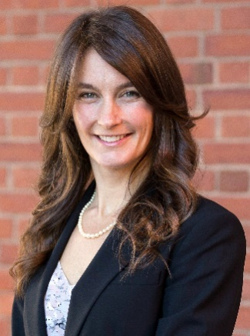
I want to congratulate our colleague Erica Steckler for putting together the PDW Program for 2023.
Erika Steckler
2023 PDW Chair

This year’s workshops cover an interesting range of topics including poverty, impact, the SDGs, humanistic leadership, and more; they promise to be informative, developmental, and engaging. In addition to these, we will have the traditional SIM-sponsored PDWs in Boston.

Please encourage your more junior colleagues to apply for the SIM Doctoral Consortium (thank you to organizers Jo-Ellen Pozner and Julia Roloff) and the SIM/ONE Junior Faculty Consortium (thank you to organizers Susana Esper and Jason Pattit). A terrific SIM Speed-Networking event will provide a setting for making new SIM acquaintances (thanks to Sarah Stephen and Pushpika Vishwanathan for putting this together). There is also an opportunity to get quality mentoring and feedback on your work through the SIM Research Development Workshop (thanks to organizers Mark Sharfman, Jegoo Lee, and Lucas Amaral Lauriano).

Finally, I would like to close with a big thank you to the SIM leadership team of Katherina Pattit, Colin Higgins, Cristina Neesham and Erica Steckler. You have been and will continue to be excellent stewards of SIM, driving our division’s flourishing and impact over the years. Thank you for your wise guidance, counsel, and collegiality, as we have worked together to put together a fantastic SIM program. I’m honored to have this opportunity to serve as 2023 SIM Program Chair, and proud of what we will offer in Boston. I look forward to seeing everyone again in August, with high anticipation for an informative and fruitful conference.

For any questions regarding this year’s SIM program, I can be contacted at SIM-abs@uva.nl.

Michelle Westermann-Behaylo
2023 SIM Program Chair

2023 SIM-ONE JUNIOR FACULTY CONSORITUM

Jason Pattit Susana Esper
University of St. Thomas IESEG School of Management
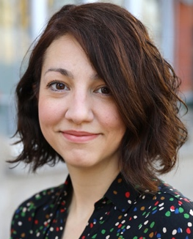
“Putting the well-being of people and planet front and center”

The SIM-ONE Junior Faculty Consortium is an annual event that provides an opportunity for early-career faculty members and postdocs who are members of the Social Issues in Management (SIM) and/or Organizations and the Natural Environment (ONE) divisions to network with senior faculty members, learn and develop their research ideas. We are happy to announce that this year, our event will be held in person in Boston!

The organizers for this year's consortium are Jason Pattit (SIM), Susana Esper (SIM), Ju Young Lee (ONE), Amanda Williams (ONE), and Christina Bidmon (ONE).

We would like to invite applicants to register for the SIM-ONE Junior Faculty Consortium. The event will take place on Friday, August 4th, 2023, from 10 am to 3 pm (Boston time). Save the date!

Under the subject “Putting the well-being of people and planet front and center,” and echoing the annual meeting theme “Putting the Worker Front and Center,” the consortium will delve into a discussion of how our research and teaching are called on to shape the role of business organizations in providing for the well-being of people and the planet. Furthermore, it is a great opportunity to reorient our attention to those who are often marginalized and silenced–including people and the natural environment–as business organizations try to navigate their ways through unprecedented turbulence and complexity.

The following senior faculty members have agreed to participate in the SIM-ONE Junior Faculty Consortium:

- Bryan William Husted Corregan EGADE Monterrey
- Cynthia Clark Bentley University
- Danielle Warren Rutgers Business School
- David Wasieleski Duquesne University
- Dirk Matten York University
- Ed Freeman University of Virginia
- Frances Bowen Queen Mary University of London
- Hari Bapuji University of Melbourne
- Harry Van Buren University of Tennessee at Chattanooga
- Jean-Pascal Gond Bayes Business School
- Jennifer Howard-Grenville University of Cambridge
- Jill Brown Bentley University
- Katherina Pattit St. Cloud State University
- Mark DesJardine Dartmouth College
- Michelle Greenwood Monash University
- Minna Halme Aalto University
- Natalie Slawinski University of Victoria
- Nicole Darnall Arizona State University
- Oana Branzei Ivey Business School
- Ralph Hamann University of Cape Town
- Sandra Waddock Boston College

2023 SIM DOCTORAL CONSORITUM
Julia Roloff
Rennes School of Business

Jo-Ellen Pozner
Santa Clara University

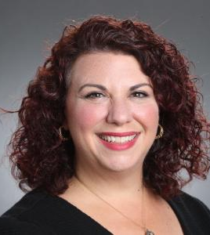
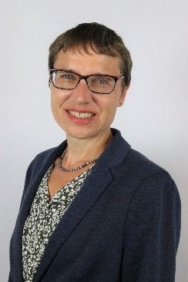
The SIM Division will offer a virtual Doctoral Student Consortium hosting a fireside chat on Thursday evening followed by a dinner sponsored by the SIM division, August 3rd and a daylong event on Friday, August 4th, 2023.

The PDW workshop aims to inspire and to inform doctoral students focusing on SIM topics about elements leading to success and impact in their scholarship, teaching, service, and lives as academics. Distinguished SIM scholars (see list below) will share their knowledge, participate in panel debates, and engage with students. Junior SIM faculty will share their recent experiences with their fruitful dissertation process, the job market, and with mastering teaching. The PDW is designed to be informative and interactive. In general, participating students will develop a ‘survival toolkit’ for their doctoral program and early professional career, as well as inspiration for making an impact in the world through your work.

The SIM Doctoral Consortium is designed for current PhD students with an interest in Social Issues in Management. We welcome participants from all stages of the PhD program to attend, though students more advanced in their doctoral program will be given priority in the event of over-subscription. SIM will pay the AOM student registration fee for SIM members who are accepted to this PDW workshop. The PDW workshop is free of charge.

Jo-Ellen Pozner and Julia Roloff
Co-Organizers of the SIM Doctoral Consortium 2023
Questions: email jpozner@scu.edu or julia.roloff@rennes-sb.com

Scheduled Presenters:
- Lucas Amaral IESEG
- John Amis University of Edinburgh Business School
- Susana Esper IESEG
- Michelle Greenwood Monash University
- Mollie Painter Nottingham, Trent University
- Colin Higgins Deakin University
- Frank den Hond Vrije University Amsterdam
- Michael Johnson-Cramer Bentley University
- Sarah Ku Loyola University Chicago
- Nancy Kurland Franklin & Marshall College
- Celia Moore Imperial College London
- Kam Phung Simon Fraser University
- Anna Roberts University of Bath
- Elizabeth Umphress University of Washington
- Milo Wang Arizona State University
- Clark Warner Boston University
- David Wasieleski Duquesne University
- Jim Weber Duquesne University

2023 SIM MEMBERSHIP COMMITTEE

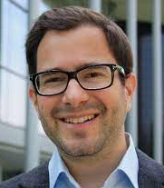
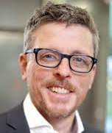

Frank de Bakker Sebastian Hafenbrädl Sarah Stephen

Dear SIM community,
We would like to share our report on the Membership Committee’s activities over the past academic year (2021/2022). Supported by the SIM governance team, we were able to bring the community together via organising several virtual events and initiatives, as follows:

- Coffee & Cocktails: We organised four C&Cs (hosted by the Division Chair Katherina Pattit, Programme Chair Cristina Neesham, and PDW Chair Michelle Westermann-Behaylo) that aimed at building a sense of community and enhancing networking opportunities. One of the C&Cs featured a special keynote by Sandra Waddock. These events attracted SIM members (past and present), but also new members, members from other divisions, and potential future members.

- SIM NETworking: In collaboration with the Research Committee, we organised the second year of SIM NETworking and the “Reconnection”, a mentoring initiative linking PhD students, junior faculty, and mid-career faculty with senior faculty mentors.

- Panel discussion on navigating the academic job market: In collaboration with the Doctoral Consortium and Junior Faculty Consortium committees, we once again organised a well-attended panel discussion with faculty representatives who were recently hiring and those who were recently hired.

- SIM Speed Networking: Working with Division Representative-at-Large Pushpika Vishwanathan (and on behalf of the Research Committee), Sarah Stephen co-organised the return of the famed Annual Meeting PDW, albeit in hybrid mode.

We also catalysed the creation of SIM Sandbox Initiative, the innovation of Kevin Chuah, Bram van der Kroft, & David Skandera. This initiative offers paper development workshops and paper presentation workshops for early career researchers.

For the AoM annual meeting week, we encouraged the community organising off-programme events and circulated the events eventually submitted to us (e.g., Socialise, Smile and Support organised by Prem Menghwar).

Contributions: We believe that these online and onsite events contribute to the division becoming more accessible and inclusive. Our events have generally been open to everyone – current members, members of other divisions, and non-members. It has brought together scholars from around the world and has offered an opportunity to meet (in most cases, virtually) other scholars and develop networks and collaborations.

We also hope that through these events, the academic community has gained a clearer understanding of the division - notably, it's values, sense of community, and availability of a fertile ground for growing as a scholar. Moreover, we are encouraging and facilitating the SIMians in organising more professional development and networking events for the community.

Next steps: On the whole, we have received encouraging feedback from the SIM community and participants of our events. For instance, participants of NETworking and attendees at the job market panel discussion have overwhelmingly indicated that they would like more such events.
Our events are also generally well-attended. Our statistics indicate that at least 50% of those who RSVP-ed to these events eventually attended, which seems above average (the average attendance rate apparently is lower).

Overall, the feedback, both formal and informal, and the attendance statistics suggests that the academic community likes to experience more of the SIM division – that they would appreciate a presence of the SIM division not only in January and July/August, but also throughout the year. This observation comes with a caveat - we have been observing that online meetings are on the decline as many are simply “Zoom fatigued”. In consequence, our aim is to continue organising events and initiatives, keeping in mind the tensions generated by “Zoom fatigue” and the need to maintain (and, hopefully, increase) the inclusivity, accessibility, and cohesivity of the division.

We are looking forward to collaborating with other committees, as well as with the SIMian community. We would particularly love to see more off-programme events and those of relevance to the academic life – such as those organised via SIM Sandbox. If you have ideas or if you would like to assist, please reach out to us!

We would also like to take the opportunity to thank the SIM governance team and committees for all the support. We are also grateful to the many scholars who dedicated precious hours - either by serving or by attending these events and initiatives.

We hope we can all continue contributing towards making the division a supportive and unparalleled home for the community!

Best regards,
Frank de Bakker (IESEG Lille)
Sebastian Hafenbrädl (IESE Barcelona)
Sarah Stephen (U. St.Gallen)

ACKNOWLEDGEMENT

We acknowledge the following SIM Communications team members who helped to produce and distribute the June 2023 SIMian issue:

The SIMian Co-editors
- David J. Skandera (Virginia Commonwealth University)
- Jae Hwan Lee (Rollins College)

SIM Communications Team
- SIM Communications Chair: Jae Hwan Lee (Rollins College)
- SIM Website Manager: Daniel Martinez (University of Leon, Spain)
- SIM Connect Manager:
  - David J. Skandera (Virginia Commonwealth University)
  - Vincenzo Vastola (Montpellier Business School)
  - Seham Ghalwash (Technical University of Denmark)
- Social Media Managers:
  - Susan Cooper(Kings College of London)
  - Zana Al-Esia (Kings College of London)
  - Lucas Amaral Lauriano (IESEG School of Management)

