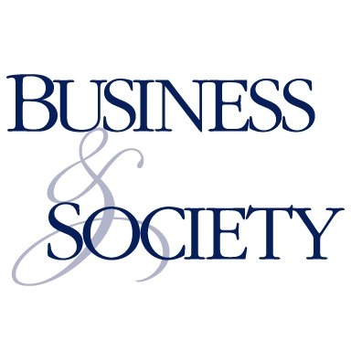 | 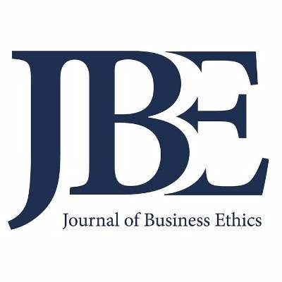

Joint Business & Society and Journal of Business Ethics Australasian Manuscript Development Workshop
10am-5pm, Friday, March 27th at Deakin Downtown, Melbourne, Australia
You are invited to submit a working paper to a joint BAS and JBE Manuscript Development Workshop. The workshop is designed to provide you with guidance in the development of manuscripts for submission to either Business & Society or the Journal of Business Ethics.
The workshop will include presentations about each journal by the editors-in-chief, a special workshop on theoretical development by Prof Andy Crane, and practical and developmental feedback to assist authors strengthen and improve their papers. We will end with an informal dinner at a Melbourne restaurant at which you are welcome to join.
Featuring:
A/Prof Michelle Greenwood, Editor-in-Chief, Journal of Business Ethics
A/Prof Colin Higgins, Co-Editor-in-Chief, Business & Society
Prof Hari Bapuji, Co-Editor-in-Chief, Business & Society
Prof Andy Crane, past Editor-in-Chief, Business & Society
Associate and section editors also available for manuscript feedback should include:
Prof Harry van Buren III
Prof Thomas Maak
Prof Steven Dellaportas
A/Prof Michael Zyphur
A/Prof Ben Neville
A/Prof Eva Tsahuridu

Working paper submission: you must submit a minimum 5 page working paper that could potentially be submitted to either journal by Monday, February 23rd. We will aim to confirm your acceptance to the workshop asap.
Acceptance to this manuscript workshop does not imply that your paper will be accepted at either journal, however, the feedback is designed with submission and eventual acceptance at these journals in mind.
Please note that there is no cost to this workshop and lunch is provided, however authors are expected to provide their own travel and accommodation if necessary. Please submit your papers to Colin Higgins (c.higgins@deakin.edu.au) or Ben Neville (banevi@unimelb.edu.au).

Proposed format:
10:00 - Journals overview by Editors-in-Chief
11:00 - Roundtable manuscript feedback
12:30 - Lunch
1:30 - Prof Andy Crane – what is theory development?
2:30 - Roundtable manuscript feedback
4:00 - Open comment and discussion session
5:00 - End
6:00 - Informal dinner

Informal queries can be directed to Colin Higgins (c.higgins@deakin.edu.au) or Ben Neville (banevi@unimelb.edu.au).

About the journals:
Business & Society publishes new scholarship based on original research. The journal will consider a wide range of theoretical, empirical (quantitative and qualitative), normative, and methodological submissions. The journal publishes both full-length articles and shorter-length research notes. Commentary pieces and rejoinders are considered on an individual basis.
The scope of business and society scholarship is broad, but all papers should in a substantial way address the societal role, impacts and intersections of and with business. Relevant subjects include: business and global governance, business and public policy, business ethics, business-government relations, corporate governance, corporate political activity, corporate social performance, corporate social responsibility, corporate sustainability, environmental management, social entrepreneurship, social innovation, stakeholder management.
Its current impact factor is 5.013.
The Journal of Business Ethics publishes only original articles from a wide variety of methodological and disciplinary perspectives concerning ethical issues related to business that bring something new or unique to the discourse in their field. From its inception the Journal has aimed to improve the human condition by providing a public forum for discussion and debate about ethical issues related to business. In order to promote a dialogue between the various interested groups as much as possible, papers are presented in a style relatively free of specialist jargon.
Its current impact factor is 3.796. It is also an FT50 journal, meaning it is one of the 50 journals used by the Financial Times in compiling the prestigious Business School research rank.

