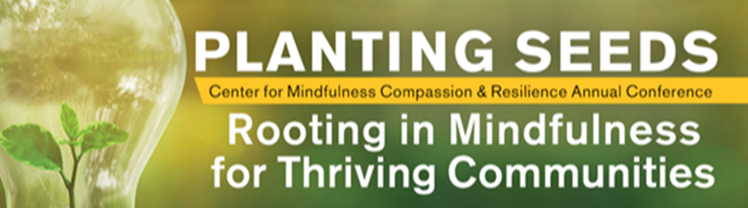

Planting Seeds: Rooting in Mindfulness for Thriving Communities
March 25th – 26th 2020, Phoenix, AZ
“Beloved community is formed not by the eradication of difference but by its affirmation, by each of us claiming the identities and cultural legacies that shape who we are and how we live in the world.” ― bell hooks
Join the Center for Mindfulness, Compassion and Resilience this year for their Third Annual Conference – Planting Seeds: Rooting in Mindfulness for Thriving Communities. We invite students, teachers, practitioners, and lifelong learners to come together and fellowship as we explore the foundations of mindfulness for building and maintaining healthy communities. We invite all levels of mindfulness practitioners, researchers and enthusiasts to come and share their methods of community building in this two-day interactive conference, and invite all community members to share in the knowledge!
Take advantage of the early bird pricing $299 NOW until Feb. 1st ($429 thereafter).
https://mindfulnesscenter.asu.edu/events/annual-conference-2020

